REPORT TO | ON
Scrutiny Committee | 10 October 2019
TITLE |  | REPORT OF
Community Safety Partnership |  | Director of Neighbourhoods and Development

Is this report confidential? | No

PURPOSE OF THE REPORT

- This report provides feedback from the Community Safety Partnership on crime statistics in South Ribble and progress in implementing priorities of the Community Safety Plan.

RECOMMENDATIONS

- To note the contents of the report.

CORPORATE PRIORITIES

- The report relates to the following corporate priorities:

Excellence and Financial Sustainability

Health and Wellbeing | x
Place | x

Projects relating to People in the Corporate Plan:

People | x

BACKGROUND TO THE REPORT

- This report provides members of the Scrutiny Committee with an update on the progress of the partnership and also progress against the key actions.
- Section 5 of the Crime & Disorder Act 1998 established Community Safety Partnerships (CSP) which is an alliance of organisations who generate strategies and policies, implement actions and interventions concerning crime and disorder within their partnership area.

CSP’s are statutorily responsible for reducing crime & disorder, substance misuse and re-offending in each local authority area. Each CSP is made up of six ‘responsible authorities’;
- Local Authority
- Police
- Fire & Rescue Service
- National Probation Service
- Community Rehabilitation Company
- Clinical Commissioning Groups

- Lancashire is a two tier authority, of which South Ribble Borough Council and Chorley Council, are neighbouring districts with similar demographic profiles. Therefore, both Chorley and South Ribble Community Safety Partnerships (‘the partnership’) work collaboratively in order to work more efficiently allowing for better communication, sharing skills, knowledge and project opportunities.

- The success of the partnership, is dependent on the collaborative working with Lancashire County Council and the valuable contributions of other partner agencies such as Registered Social Landlords, Drug & Alcohol Services Citizens Advice Bureau, voluntary community faith sector (VCFS) organisations and commissioned services.

PROPOSALS (e.g. RATIONALE, DETAIL, FINANCIAL, PROCUREMENT)

- Overall Position
In 2018/19 the partnership has achieved its main objectives and identified areas for review and different ways of working. With the shared commitment to improve community safety outcomes, the partners in the Community Safety Partnership (CSP) will continue to work collaboratively to ensure that South Ribble remains a safe place to be. The partnership delivers well in view of the limited resources afforded to it.

South Ribble is a relatively safe place in which to live, work, play and visit. In many areas of South Ribble crime and community safety issues are better than the national and, or, the North West regional averages.

- Areas of Significant Progress/Achievement

Operation Genga; a local organised crime partnership board which includes South Ribble Council and other agencies. This is to ensure that all available information and powers are effectively used in order to disrupt organised crime.

Lancashire Prevent Delivery Group; the Lancashire twelve districts work together to meet the prevent duty section 26 of the Counter Terrorism & Security Act 2015.

Hate Crime; The agreement and implementation of the Hate Crime Strategy 2017-2020 will inform future collaborative working of public and other organisations in order to positively respond to the reporting of hate crime and hate incidents.

Community Warning Notices; Community Protection Warnings (CPW) is an option when informal measures have been exhausted and Anti-Social Behaviour continues. The CPW, is a formal warning given and is usually the final warning prior to issuing a Community Protection Notice, which if breached could lead to the issue of a Fixed Penalty Notice or prosecution.
So far they have been used for the following reasons:
- Domestic Waste
- Fly Tipping on Private Ground
- Anti-Social Behaviour
- Control of Dogs
- Animal faeces
- Bonfires

CCTV;
Both South Ribble and Chorley Council have agreed to jointly fund CCTV cameras to be installed at each end of the Moss Lane underpass in Leyland. This investment is following a series of meetings which have included the Police, LCC, Highways England. The purpose of the meetings is to agree a strategy in which to reduce ongoing and persistent anti-social behaviours, including a serious assault which resulted in a man being hospitalised.
Additionally, an additional financial commitment of £10,000 has been made to install CCTV in Leyland Town Centre.

New Neighbourhood Policing Model;
The neighbourhood policing structure and function was reviewed in 2018 under the Core Services Review and Modernising Neighbourhood Policing Project. This has provided an increase of four police officers. Please see the South BCU structure below.

The ambition is to continue to ‘keep people safe and feeling safe’ using the following three primary tactics;
- Engage with communities
- Problem Solving
- Targeting

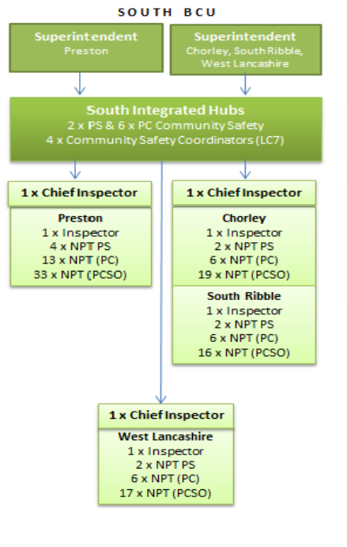

- Areas for Further Action/Monitoring

All responsible authorities to embrace equal responsibility, foresight and commitment to effectually utilise the Office of Police and Crime Commissioner (OPCC) grant available to the partnership.

All responsible authorities to proactively contribute and commit resources to the development and delivery of the community safety partnership action plan 2019-22.

It is clear from the current trends, which mirror the national picture, that the Community Safety Partnership is facing a significantly challenging climate in which to reduce crime, disorder and anti-social behaviour.

- Progress against Key Actions/Projects
Crime Figures

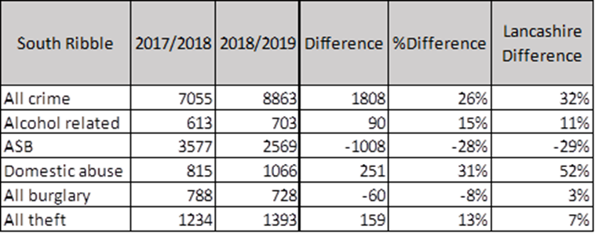

Multi-Agency Risk Assessment Conference (MARAC)

A MARAC listing high risk cases of domestic abuse is held each month. The multi-agency meeting facilitates the sharing of up to date information. Actions are put in place in order to safeguard the victims, children and other vulnerable members of the household.

The most up to date figures for the Chorley & South Ribble MARAC as of July 2018-June 2019 shows that between:
• 325 Cases were discussed
• 467 Children in the household
• 3 Victims aged 16-17
• 0.9 % Declared having a disability
• 6.2 % Males

The Independent Domestic Violence Advocates (IDVA) Service

The OPCC is the contracting authority responsible for procuring the victims’ services. The
OPCC procured the IDVA service delivery to form Lancashire Victim Services as of 1 April 2017 until 31 March 2020. There is an option to extend the provision of services funded under the contract in 12 month increments from 01 April 2020 until 31 March 2022.

The council provides a financial contribution to the service provision of IDVA support for victims of domestic abuse assessed to be either medium or high risk.

Specialist Domestic Violence Courts (SDVC)

The SDVC continues to operate each Wednesday from Preston Magistrates Court for South Ribble cases. A SDVC forms part of a co-ordinated response to tackling domestic abuse.

The Sanctuary Scheme

The Sanctuary Scheme works in partnership with the registered social landlords and provides target hardening as an option for victims of domestic abuse to feel safer in their own homes. The service is coordinated by the SRBC housing options team who manage the referrals from partner agencies. The safety installations are provided by Preston Care and Repair. This provides an option for victims of domestic abuse who may be settled in the area with good support networks to remain in their own homes rather than having to move the family to another area in order to feel safe.

Child sex exploitation

The dedicated multi- agency support team for the South Ribble area is DETER who work tirelessly to action plan and safeguard victims of CSE to help them to escape the abuse as well as holding perpetrators to account.

Targeting child sexual exploitation (CSE) is national priority and has a high media profile.
It is also a priority for Lancashire Constabulary and the Partnership. The overall picture of
CSE within South Ribble is identified as single victim / single offender type offending. The police have an active deter team working in the division which manages intelligence, perpetrators and locations. Partnership working is essential especially in the instance of vulnerable/missing children from home. It is acknowledged that the ‘selfie’ and ‘sexting’ culture is increasing the risks faced by children and young people. A video has been produced by the West Lancashire Community Safety Partnership on sexting and this is being shown in schools in the South Ribble area.

- Crime Reduction

Multi Agency Meetings

A number of multi-agency meetings and groups are in place to support crime reduction.
These include:

MATAC (Multi Agency Tasking and Co-ordination) supports the Council’s approach to neighbourhood working/management and aims to tackle crime and anti-social behaviour issues at a local level. It focuses on information sharing and the tackling of local issues, problematic households/individuals and problem solving. The MATAC is made up of officers from a range of partners who can all contribute towards community safety and dealing with local crime and nuisance.

Operation Genga focuses on the pursue element of the Serious Organised Crime Strategy. Bi monthly multi-agency meetings are held to discuss referrals and intelligence in relation to organised or the potential of organised crime. This can include counterfeiting, CSE, drug supply and financial crime. The meetings are chaired by the Community Safety Officer with support from the Police, Genga Coordinator.

SRIT (South Ribble Integrated Team)
The core purpose of the South Ribble Integrated Team is to make a positive difference to the lives of vulnerable adults and their families, ensuring that the right services are offered at the right time. The South Ribble Integrated Team will ensure maximum benefits are delivered using available resources, in order to achieve the desired outcomes for the vulnerable adult or for the family, to prevent further escalation of need.

The Violence Reduction Unit provides a forum focused on knife crime in particular. A successful application was confirmed by the Home Office in August for the unit. The total funding allocated for Lancashire is £1,160,000. This funding will be used for education, diversionary activities, use of knife wand and bins. A Violence Reduction Unit Partnership Board will be established which would remain until 31st March 2020 to look at a public health approach to violent crime and staff will be seconded into this unit.

Strategic Hate Crime and Cohesion Strategy Group. The overarching aim is to make the people of Lancashire safer by the elimination of Hate Crimes and Incidents.

Lancashire Prevent Delivery Group works in Partnership to meet the Prevent Duty
To ensure Specified Authorities implement required duties in line with section 26 of the Counter Terrorism & Security Act 2015. To develop learning and share best practice across Lancashire on the Prevent agenda to safeguard individuals and groups from being drawn into radical and extreme behaviour that could lead to terrorism

Lancashire Reducing Reoffending Board provides the framework to allow for collaborative working in order to provide a coordinated response in which to manage offenders, reduce reoffending and integrate into the community. The Integrated Offender Management (IOM) responds and commits resources to working with offenders who meet the criteria, as detailed below.
- Violence Against a Person
- Domestic Abuse Perpetrators
- Sex Offenders
- Serious / High Impact Acquisitive Crime & ‘Others’

Anti-Social Behaviour County Group is a bi monthly meeting of community safety leads and Police which provides an opportunity to problem solve, share good practice and work jointly on specific anti-social behaviour issues that may have a cross border impact.

Pan Lancashire Domestic Abuse Strategic Board monitor overall delivery of the DA Strategy and Action Plan. Receive reports from Area Groups, DHR Steering Group, DA Commissioning Group and LDAF/Provider Group - and respond to issues and concerns that have an impact at a County level. Co-ordinate DA Campaigns and Awareness Raising Programmes pan-Lancashire (allowing for area variations).Oversee delivery of support services for victims—including development of new models and approaches such as “Change That Lasts”. Lead on identifying areas of development / support for potential funding opportunities

- Operations
Several operations are held during the year to target anti-social behaviour and other current seasonal issues including the following operations:

Operation Tarka – Targeting Immigration, Licensing, underage knife sales, drug warrants.
Tesco’s Carpark – ASB and Driving Concerns
Churchill way – Tackling ASB
Factory Lane – Tackling ASB
Brite Sparks – Fire Safety around bonfire night.
Dans car – Highlighting road and driver safety

- The CSP funding has enabled:
  - Kingsfold Community Engagement Project – Strengthening Community Cohesion
  - County Lines awareness raising in High Schools, learning through drama - Raising awareness of the grooming process and being forced into drug supply and distribution.
  - PNE Kicks – PNE Community Team (Bamber Bridge Leisure Centre )
  - Shed Break Packs – Following shed breaks to re secure.

- Funding Position
South Ribble Community Safety Partnership is allocated £10,000 in grant funding. Each of the responsible authorities has shared responsibility for accessing OPCC funding.

SRBC has committed £24K total contributions to the IDVA service in the three years from April 2017 to March 2020.

- Safer Chorley and South Ribble Community Safety Partnership Annual Conference
The focus of the conference was on serious and organised crime with guest speakers from Local Neighbourhood Policing Teams and Regional Organised Crime Unit. The conference also provided that first consultation on the three years community Safety partnership Plan 2019-2022

- Community Safety Partnership Plan

The key priorities for South Ribble and Chorley derived from the Strategic Needs Assessment local profiles which are managed on a broader scale working with Lancashire County Council, Unitary Authorities and the 12 district Authorities:

• Counter terrorism
• Violence: domestic assault
• Hate: incidents and crime
• Collisions: Killed / Serious Injury
• Child abuse
• Domestic abuse
• Human trafficking
• Sexual: rape

In addition, the Partnership has agreed to use available resources to address the following priorities:

CHORLEY & SOUTH RIBBLE COMMUNITY SAFETY PARTNERSHIP PRIORITIES 2019-2022

VULNERABILITIES-
domestic abuse vulnerable adults, substance misuse, Hate crime.
SERIOUS & ORGANISED CRIME-
terrorism, exploitation, human and drug trafficking
ANTI-SOCIAL BEHAVIOUR –
nuisance, crime and disorder, noise, mental health, problems with neighbours

CONSULTATION CARRIED OUT AND OUTCOME OF CONSULTATION

- Consultation has been undertaken via a the strategic assessment (SA) which is one of the statutory requirements for community safety partnerships as outlined in the Crime and Disorder Act 1998. The SA is a rigorous process designed to provide an account of long-term issues and threats from crime and anti-social behaviour (ASB) across Lancashire.

- The assessment is undertaken every three years using The MORILE (Management of Risk in Law Enforcement) tool to rank the various threats and issues identified by Lancashire Constabulary.

- In addition to this, the Office for National Statistics has developed a weighted measure of police recorded crime known as the ‘crime severity score’. The scoring mechanism considers the volume and severity of an offence, in order to reflect the relative harm to society and demands for police. This data is also cross referenced with the areas of most concern, identified by the public through the ‘Living in Lancashire Survey’.

- The data is analysed to create individual local profiles to inform the partnerships key priorities to aid strategic decision-making. The information is then used to inform the local strategy in which to reduce crime and disorder, substance misuse and re-offending.

Financial implications

- The revenue costs of the supporting the Community Safety Partnership are included in the Council’s budget. A capital budget allocation of £10,000 for the installation of CCTV in Leyland has been approved

LEGAL IMPLICATIONS

- Section 5 of the Crime & Disorder Act 1998 established Community Safety Partnerships (CSP) which is an alliance of organisations which generate strategies and policies, implement actions and interventions concerning crime and disorder within their partnership area.

- South Ribble Borough Council has a statutory duty for reducing crime & disorder.

AIR QUALITY IMPLICATIONS

- None.

COMMENTS OF THE STATUTORY FINANCE OFFICER

- The report is an update on progress and therefore there are no direct financial implications. The Council’s role in the Community Safety Partnership is set out in the report and the financial implications, including staffing resources are contained within existing budgets.

COMMENTS OF THE MONITORING OFFICER

- There are no legal concerns arising from this report. Clearly to tackle effectively the complex and difficult challenges facing society from the point of view of crime and disorder it is imperative that all relevant organisations work together effectively. Good communication channels is crucial to this. In the South Ribble area there is clearly no shortage of good practice taking place. Fundamentally we must act in accordance with our statutory duties to what we can to reduce crime and disorder.

OTHER IMPLICATIONS:

- HR & Organisational Development  - ICT / Technology  - Property & Asset Management  - Risk  - Equality & Diversity | See above report.

BACKGROUND DOCUMENTS

There are no background papers to this report.

APPENDICES

There are no appendices to this report.

Report Author: | Telephone: | Date:
Jennifer Mullin, Director of Neighbourhoods and Development | 01772 625329 | 01/10/19

